Week 1 Practical Homework for Thursday: Causal Inference applied to climate series

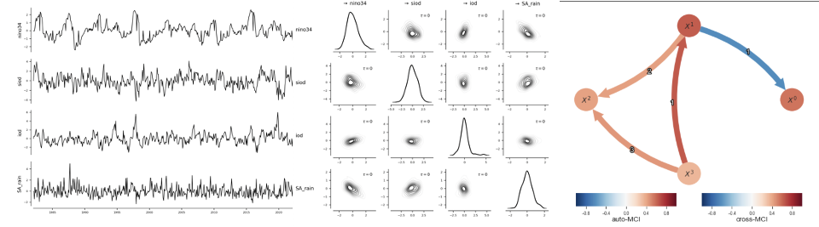
Analysing timeseries of climate indices is a powerful yet simple approach to diagnose connections between remote places on earth’s surface. We call these teleconnections. The El-Nino to Southern Africa teleconnection is well-studied and understood. From studies which look at atmospheric circulation, we have strong evidence that the correlation between El Nino and southern African rainfall is casual, as in El Nino causes southern African droughts. But correlation alone cannot tell us this. Jakob Runge lead writing of a high-level article in which the need for causal analysis in earth and climate science is motivated: Casual Inference for Timeseries. This follows up on an earlier article about the same topic: Inferring causation from time series in Earth Systems science.
Homework Reading 1: Read the abstracts and look at figures and figure captions of these papers, but especially the first one.
(With thanks to Jaron Cohen, AIMS TA 2025, who compiled the text and links below).
There are a number of Medium articles published by Jakob Runge and Kenneth Styppa on Causal Inference. You do not need to read all of them nor do you need to understand everything within them, but they should help to clarify some of the concepts and put things in perspective.
Articles in the Series:
Homework Reading 2: Read these three - they’re really short and should answer a few of the “why” questions you might have.
1. https://medium.com/causality-in-data-science/why-machine-learning-needs-causality-3d33e512cd37
2. https://medium.com/causality-in-data-science/what-is-causal-machine-learning-ceb480fd2902
3. https://medium.com/causality-in-data-science/what-are-causal-graphs-abdb50354c8a
The following articles delve into some of the more technical definitions. Do not read these now, but they would be important if you wanted to deeply understand the algorithms that you are using in Tigramite, the python package the practical will start using on Friday.
1. https://medium.com/causality-in-data-science/confounding-colliding-d-separation-and-sleeping-with-shoes-on-8ba43c976354
2. https://medium.com/causality-in-data-science/assumptions-for-causal-discovery-cc194d607a14
3. https://medium.com/causality-in-data-science/introducing-conditional-independence-and-causal-discovery-77919db6159c
Although this 3rd article uses a lot of the concepts defined in the previous ones, it still talks about some things at a high-level that would be useful. In particular, the following quote is important:
The two tasks of causal inference
In essence, there are two tasks in causal inference and their difference resides in their distinct starting point.
Task 1 uses already existing qualitative knowledge about causal relationships to build a directed acyclic graph which is then used to quantitatively estimate causal effects. Here we refer to this task as causal effect estimation.
Task 2, on the other hand, starts from a blank slate. You have no clue about how your variables could be related and therefore go on an adventurous discovery journey to find out. This task is also called causal discovery.
The final four articles in the series are below. I’d recommend looking at the first one to get a more concrete idea of what an SCM is. The second one goes through how PCMCI works - you can hold off on this one until you feel more confident until later if you want. The third and fourth get hands-on with the Tigramite package on some examples - these could be helpful, but don’t spend time on things you haven’t necessarily seen before.
- https://medium.com/causality-in-data-science/structural-causal-models-a-quick-introduction-1ab49259e921
- https://medium.com/causality-in-data-science/causal-discovery-with-multivariate-time-series-data-a3f7ffc16747
- https://medium.com/causality-in-data-science/hands-on-causal-discovery-with-python-e4fb2488c543
- https://medium.com/causality-in-data-science/hands-on-causal-effect-estimation-with-python-aac40ca2cae0

